
Sreenidhi Institute of Science and Technology
(An Autonomous Institution)
Regulations:
A14
Code No: 4H315 Date:1-Dec-16(FN)
B. TECH. II-Year I-Semester Examinations, Nov/Dec 2016 (Supplementary)
ENGINEERING MATHEMATICS-III (Common to all Except-BT)

Time: 3 Hours Max. Marks: 70
Note: a) No additional answer sheets will be provided.
b) All sub-parts of a question must be answered at one place only, otherwise it will not be valued.
c) Assume any missing data.

Part - A
Max.Marks:20

Answer all QUESTIONS. EACH QUESTION CARRIES 2 MARKS.
1. Prove that 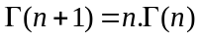
2. Write Cauchy – Riemann equations in polar form.
3. Write Parseval’s identity for Fourier transforms.
4. Derive Newton – Raphson’s iterative formula to find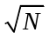.
5. Evaluate 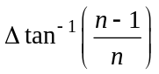
6. Write Taylor’s series expansion to find y(x₁) when you are given y¹ = f(x, y)
and y (x₀) = y₀.
7. State Cauchy’s theorem to evaluate complex integrals.
8. State Trapezoidal rule.
9. Prove that 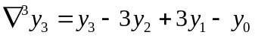.
10. Prove that 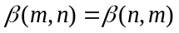.
Part – B
Max.Marks:50

ANSWER ANY FIVE QUESTIONS. EACH QUESTION CARRIES 10 MARKS.

1. a) Derive the relation between Gamma and Beta functions
b) Using the properties of Gamma and Beta functions prove that 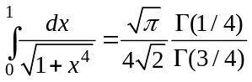

2. a) If the potential function is 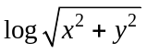 find the flux function and the complex
potential function.
b) Evaluate 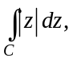where C is the contour
(i) Straight line 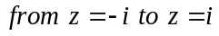

(ii) Left half of the unit circle 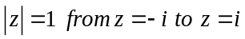

3. a) Find the Fourier sine transform of 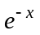. Hence show that 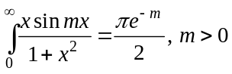.
b) Using Parseval’s identity, prove that 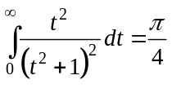.

4. Evaluate 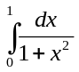 using Simpson’s 3/8 rule taking h = 1/6. Hence obtain an appropriate value of π.

5. Find Lagrange’s interpolation polynomial for the following data and hence find f(2).
x | 0 | 2 | 3 | 6
f(x) | 648 | 704 | 729 | 792

6. Apply the fourth order Runge – Kutta method, to find ‘y’ when x = 0.1, 0.2, 0.3 given that dy/dx = xy+ y² and y(0) = 1.

7. Write Laurent’s series expansion of 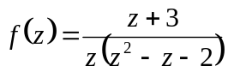in the regions
(i) 0 < |z| < 1
(ii) 1 < |z| < 2
(iii) |z| > 2

8. Find a real root of the equation 2x–log₁₀ x = 7 by the method of iteration.
-- 00 -- 00 --

